**Web Diagram:**

**Website url: https://cp-frontend-red.vercel.app/**

**Backend:**

**Project initializer:** npm init –y

**Package.json:**

**Environment:**

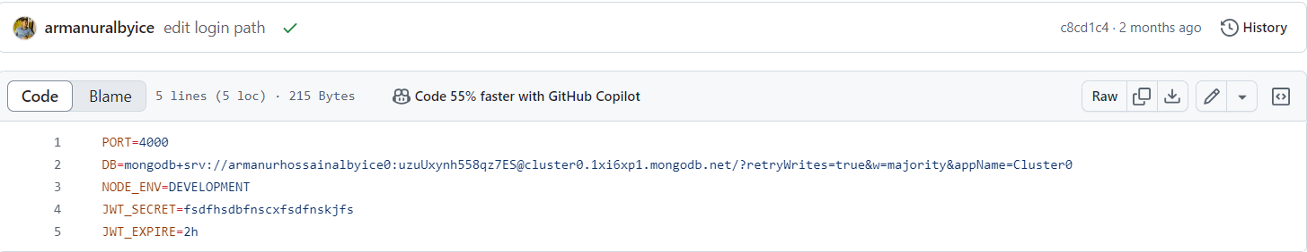

**Error Handling:**

**Explain:** Explain the above code

**Middleware:**

**errors.js:**

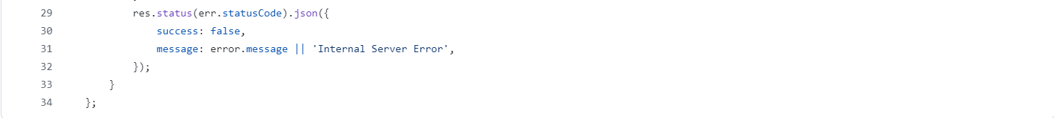

**Explain:** Explain the above code

**catchAsyncError.js**

**Explain:** Explain the above code

**Auth.js**

**Explain:** Explain the above code

**SendEmail.js**

**Login UI Creation:**

**Authentication:**

**Generate jwt token:**

**Explain:** explain the above code

**Login Controller:**

**Explain:** explain the above code

**Routing Loin Controller:**

**Explain:** explain the above code

**Admin Access:**

**Admin Dashboard:**

**url:** <https://cp-frontend-red.vercel.app/home>

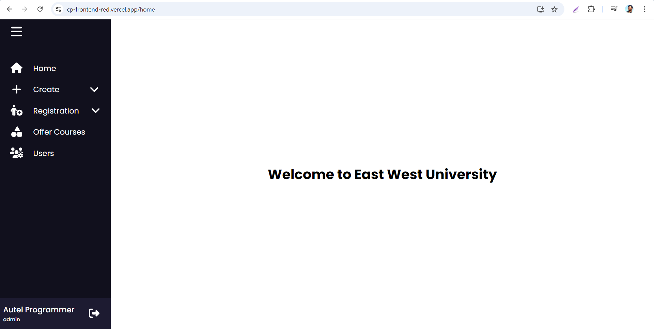

**Create Department:**

**Department UI:**

url: https://cp-frontend-red.vercel.app/department

**Explain:** explain the above page

**Department Model:**

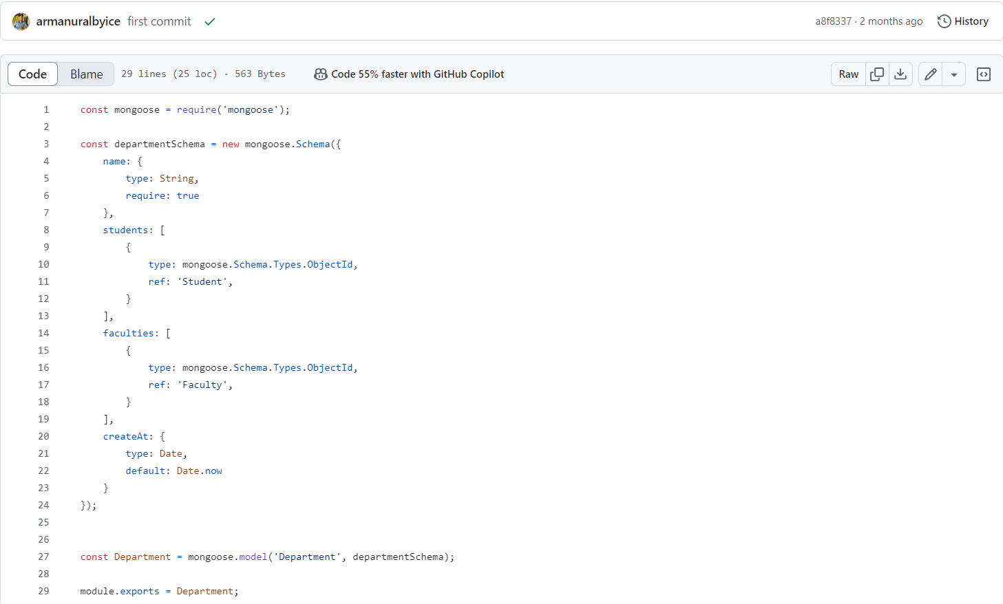

**Explain:** explain the above code

**Department Controller:**

**Explain:** explain the above code

**Department Routing:**

**Explain:** explain the above code

**Create Semester:**

url: <https://cp-frontend-red.vercel.app/semester>

**Semester UI:**

**Explain**: explain the above page

**Semester Model:**

**Explain:** explain the above code

**Semester Controller:**



**Explain:** explain the above code

**Semester Routing:**

**Explain:** explain the above code

**Add Course:**

url**:** <https://cp-frontend-red.vercel.app/course>

**Course Model:**

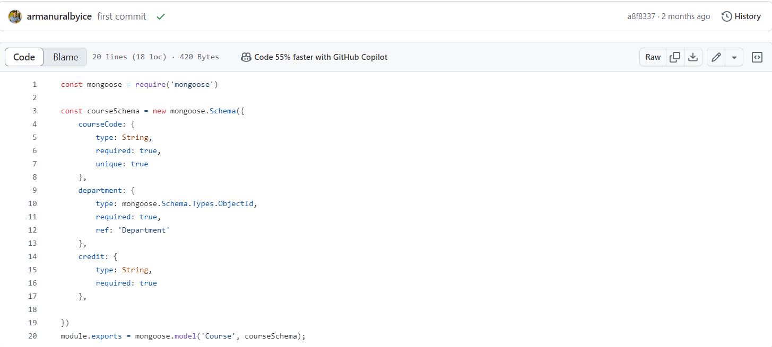

**Explain:** explain the above code

**Course Controller:**

**Explain:** explain the above code

**Course Routing:**

**Explain:** explain the above code

**Registrtion Users:**

**Student Registration:**

url: https://cp-frontend-red.vercel.app/student

**Student Add UI:**

**Explain:** explain the above page

**Student Model:**

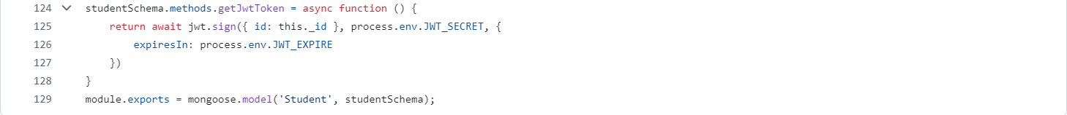

**Explain:** explain the above code

**Student Controller:**

**Explain:** explain the above code

**Student Routing:**

**Explain:** explain the above code

**Faculty Registration:**

url: https://cp-frontend-red.vercel.app/faculty

**Faculty Add UI:**

**Explain:** explain the above page

**Faculty Model:**

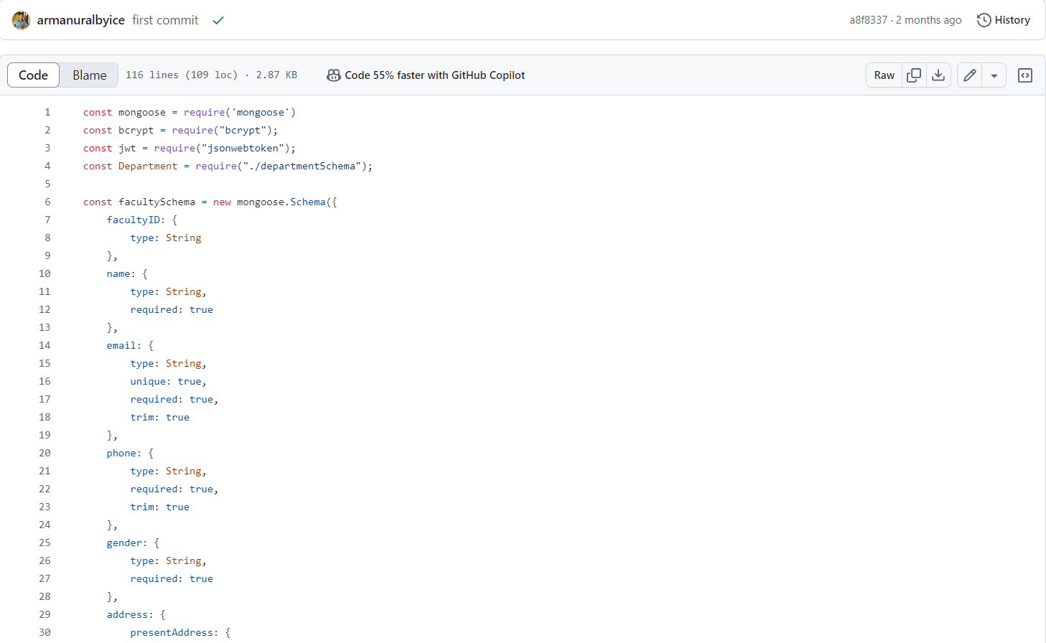

**Explain:** explain the above code

**Faculty Controller:**

**Explain:** explain the above code

**Faculty Routing:**

**Explain:** explain the above code

**Admin Registration:**

url: https://cp-frontend-red.vercel.app/admin

**Admin Add UI:**

**Explain:** explain the above web page

**Admin Model:**

**Explain:** explain the above code

**Admin Controller:**

**Explain:** explain the above code

**Admin Routing:**

**Explain:** explain the above code

**User’s grid list UI:**

Url:<https://cp-frontend-red.vercel.app/users>

**Explain:** explain the above web page

**Create Classroom:**

url: https://cp-frontend-red.vercel.app/classroom

**Classroom UI:**

**Explain:** explain the above web page

**Classroom Model:**

**Explain:** explain the above code

**Classroom Controller:**

**Explain:** explain the above code

**Classroom Routing:**

**Explain:** explain the above code

**Offer courses by semester:**

**url:** https://cp-frontend-red.vercel.app/offer-course

**Offer Courses UI:**

**Explain:** explain the above web page

**Offer Course Model:**

**Explain:** explain the above code

**Offer Course Details Model:**

**Explain:** explain the above code

**Offer Course Controller:**

**Explain:** explain the above code

**Offer Course Routing:**

**Explain:** explain the above code

**Offer courses grid list UI:**

Url: <https://cp-frontend-red.vercel.app/offer-course/list>

**Explain:** explain the above web page

**Student Access:**

**Student Dashboard:**

**url:** <https://cp-frontend-red.vercel.app/home>

**Advising:**

**url:** <https://cp-frontend-red.vercel.app/advising>

**Explain:** explain the above web page

**Advising Model:**

**Explain:** explain the above code

**Advising Controller:**

**Explain:** explain the above code

**Advising Routing:**

**Explain:** explain the above code

**Server.js**

**Explain:** explain the above code (note: sob ses e amra sob route gola server.js e call kore disi cause eita root file server.js theke project run kore and bibinno route call kora amader request er response provide kore).